M. Lynette Thompson Library

Handbook for Operations
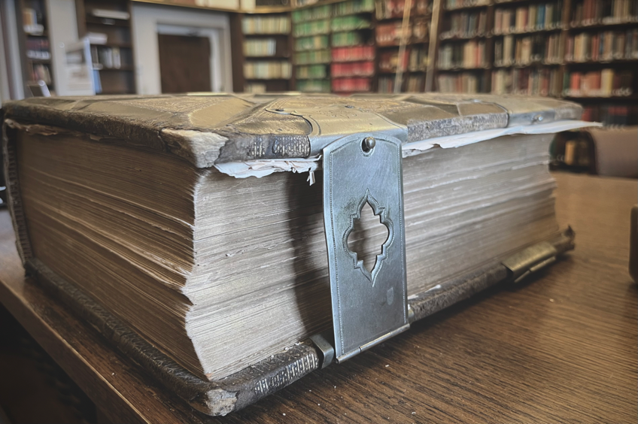

UPDATED SEPTEMBER, 2022

I. HISTORY OF THE M. LYNETTE THOMPSON LIBRARY:

The original core of the books in the library was assembled by Dr. Lynette Thompson, when she was chair of the Classics Department for 19 years (1961-1980). Dr. Thompson taught at Florida State College for Women/Florida State University from 1942 until 1994, holding the longest tenure of any faculty member at FSU. She specialized in the poetry of Lucan, and was known in the State of Florida and around the U.S. for promoting the Classics. Dr. Thompson passed on in 2003. The library had been named in her honor in 1996 and she had the pleasure of seeing it established in its current home in Dodd Hall.

II. THE LEON GOLDEN FUND FOR LIBRARY ACQUISITION:

In December 2005, the Department of Classics received a generous gift from Leon Golden, Professor Emeritus of Humanities and Classics at FSU. Professor Golden’s donation established a fund to be used by the department for acquiring books for the Thompson Library. The interest that accrues from the fund’s principal constitutes the spendable income to be used for purchasing new books. Naturally this amount varies from year to year. At the start of each new academic year it will be the responsibility of the Thompson Library Committee to inform the faculty of the amount of spendable money in the fund.

The Department of Classics is honored to be the recipient of so generous a gift, which is a testament to Professor Golden’s unwavering commitment to the study of the ancient world at FSU. Professor Golden’s generosity has enabled us proudly to uphold his steadfast belief that great universities must have great libraries.

III. POLICY AND METHOD FOR PURCHASING BOOKS:

The Thompson Library Committee will be responsible for new purchases. It will solicit requests for new acquisitions from faculty at the start of each academic year and will make purchases based on these requests. Purchases will aim at the acquisition of materials that have broad appeal and usefulness for the library’s clientele of graduate students and faculty. To that end, the committee should strive to acquire a wide range of standard reference works (e.g. LIMC, concordances, dictionaries, encyclopedias, handbooks, etc.), critical editions of texts, commentaries, companion volumes, collections of inscriptions, and general archaeological works (e.g. Beazley’s volumes on Attic vase painting, Mountjoy on Mycenaean pottery, etc.) and other items that will be of use to faculty and graduate students for research, teaching, and graduate exam preparation. In general, preference should be given to completed projects (e.g. LIMC) as opposed to open–ended and prohibitively expensive series and journals (e.g. Corpus Vasorum Antiquorum).

The normal method for purchasing books is as follows: once the Thompson Library Committee has approved the acquisition of a given book, the faculty member who requested its purchase will be asked to pay for the book up front. This amount will be reimbursed in full with money from the FSU Foundation; receipts for all purchases are required in order for the department’s Office Manager to process any requests for reimbursement.

IV. GENERAL REGULATIONS FOR USE OF THE THOMPSON LIBRARY:

- The library shall be kept locked at all times. Admission is by key card only.
- Classics faculty and graduate students may use the library at any hour.
- No food or drink, including bottled water, is allowed in the library. This rule will be strictly enforced.
- This is a non-circulating library. Books must remain in the room. All books should be replaced in their proper place on the shelf.
- In exceptional circumstances faculty or graduate students may remove a book from the room for use in a class or for photocopying. The book must be returned promptly.
- Books on reserve for Classics courses will be placed on the shelves in the front of the room. These should be returned as appropriate.
- The library is for reading and studying, and not for group discussions or conversations. No talking or conversation is permitted. Group class preparation should be done in the lounge or other public places, not in the library. Users should show the greatest courtesy and consideration for those who are working in the library.
- Note that one-half of the room in which the Thompson Library is located is dedicated to the library of the FSU Department of Religion. It is the policy of the Classics Department to share the room with the utmost courtesy and respect for colleagues and students from Religion. Classics avoids using the Thompson for any events unrelated to the library that might cause a distraction or interruption to those accustomed to using the space.

V. REQUESTING A RESERVE SHELF FOR COURSES:

At the start of each semester, the Chair of the Thompson Library Committee will ask the department’s faculty members if they wish to have a shelf for reserve materials to be used in their courses. These shelves, located in the front of the library near the door, will be clearly marked by labels containing course names and numbers.

VI. PERIODIC BOOK SALES:

Given that space in the library is at a premium, and also in order to generate additional funds for the maintenance of the collection, the Thompson Library Committee will periodically hold book sales on the landing outside the library. The date of such sales is subject to the approval of the department and once agreed upon the date of each sale will be publicized as widely as possible.
The order of priority for culling books for sale is as follows: 1. Duplicates; 2. Old and/or outdated editions of texts and school texts; 3. Journals.

VII. LIBRARY CATALOG:

The Thompson Library catalog can be accessed by going to LibraryThing.com.

APPENDIX: Policies and Procedures for Thompson Library Staffers

The following instructions are intended to assist those who are hired as staffers for the Thompson Library.

Initial sorting upon acquisition:

In addition to purchasing books desired by the departmental faculty, the Thompson Library often receives donations of books in varying quantities. These can be a handful at a time or hundreds arriving at once. When donated books arrive, go through them and separate out those books that are appropriate for the collection from those that are either irrelevant or transient, such as fiction and pedagogy. Books deemed undesirable for the collection are to be set aside for inspection by the Thompson Library Committee, who will determine whether or not to mark them for de-accession.

Cataloging:

The Thompson Library uses the Library of Congress Classification, or call number, the system employed by all other FSU Libraries. Books destined to become part of the library’s collection are not under the purview of Florida State University, and therefore need to be entered into our own online catalog. The library uses LibraryThing.com, an online service that provides easy access to a number of book information sources, including the Library of Congress and Amazon.com, plus many university catalogs worldwide. To add books to our catalog, go to LibraryThing.com and log in.

Once you are logged into the site, you will find several options for interacting with our catalog, but to enter a book into the system, click the tab labelled “Add Books” at the top of the page. Next, enter the title of the book into the Search Box, making sure the bullet next to Amazon.com is checked (further down on the left side of the page), and press Enter. You may need to try another source, but Amazon.com seems to have most books. Now, a list of possible matches will appear on the right side of the page. If you see the book you were looking for, simply click the title in the search results to add the book to the catalog.

If the search failed to locate your book, try adding more information to your search (author, date, etc.). Another option is to search the Library of Congress or any other of the 700 possible sources available, checking the appropriate bullet and repeating the search. When you have located the book, simply click the title in the search results to add it to the catalog.
Some books will still prove to be elusive, but luckily we have an option of last resort. Simply click the “Add Manually” link under “Other Options” at the bottom left of the “Add Books” page.

Finally, you need to check/add the book’s details. To do this, click the option to “Edit Book”, often represented by a pencil icon. (If you chose to add a book manually, you should already be on the edit page) The more information you have here, the better. Check any information already present with the publication page of the book itself and add anything you find missing. If you never found a call number for the book, enter “No Call #” as a tag for easy access later. When you are finished, click “Save”. That’s it, the book is now cataloged!
Designate (or locate) a shelf or pile for those books with call numbers, keeping them in order for easier labelling later. Designate (or locate) another shelf or pile for those books without call numbers. Repeat this step for all remaining books.

Labelling:

Each book’s call number must be printed on special labels and affixed to the book’s spine using a heat plate. Unfortunately, we do not have the equipment in Dodd Hall to print these labels. The labelling process thus requires a visit to Library Technical Services (LTS), so it is recommended that you finish cataloging all books beforehand. The following recommendations are based on the situation at LTS in 2014, and are subject to change.

Once you are ready to make the labels, contact Ms. Theresa Haworth (thaworth@fsu.edu) at 850-645-7461, and Mr. Albert Hall (ahall@fsu.edu ) identifying yourself and indicating when you would like to come in. This is not absolutely necessary, since the people at LTS will be happy to assist you even if you just drop in, but it is nice to give them advance warning of your arrival.

The LTS building is currently located at 715 West Madison Street, five blocks south and two blocks west of Dodd Hall. They have parking on the west side of the building for faculty and staff, and nearby metered parking for those without parking permits. Once you enter the building, Theresa will likely come to greet you and direct you to Al, who will explain how to use the label printer. If no one is available to assist you, which is unlikely, you can follow these instructions (but you will need someone to sign in at the computer):

- From the door, follow the path along the right side of the room, past the main desk on the right, and you should see on your left a pair of computers facing each other, each next to a dot matrix printer loaded with label paper.
- Once someone has signed you in to the computer, you should see an open window titled “LabelPrnA-FS”, or something similar. The only two things in this window relevant to your task are the box that says “Call Number” and the “Print” button on the toolbar.
- Open a web browser, access our catalog at LibraryThing.com and click the “Your Books” tab. By default, the list is sorted to the order in which they were entered, so find the book tagged with “Last book with a label” and work up from there.
- For each book, copy and paste the call number from our catalog to the call number box in the label printing window. Before you click the “Print” button, format the label. The standard format is to put each item on a separate line; for example D / 547 / .A8 / M7 / 1958 (where each “/” represents a new line). Some books have only two lines, others have up to five, so just follow the basic pattern of the example. (Note that the third item begins with a period.)
- Press the “Print” button.
- Repeat the above steps for each book.
- When you have finished printing all labels, tag the last book as “Last book labelled” and delete that tag from the book that had it before. Logout, close all windows except the “LabelPrnA-FS” window, and press the “Micro Feed Up” on the printer itself (fourth button from left) until your printed material is past the mechanism holding the roll of paper in place. Cut beyond the mechanism (so they don’t have to rethread the paper) and collect your labels!
- Thank everyone at LTS for being so very helpful and nice, then return to the Thompson Library.

Applying Labels to Books:

Plug in the heat plate and set the dial to 5. It takes about ten minutes to heat up. If you shelved/piled the books in order while entering them into the catalog, this process should go smoothly, if a bit monotonously. Cut a full label horizontally from the roll and then trim it to fit the spine of the book at the bottom. Place it directly on the book, not on the dust jacket. Remove the backing, stick the label on the book, and place that spot directly onto the heat plate for a few seconds, rocking the book if needed to heat the label evenly. This should take no more than about five seconds. Make a new shelf or pile for your newly labelled books.

Shelving:

With only a few books to shelve, you can easily file each book away as you label it. But you will discover quickly that you are running out of space, in which case you should finish the labelling first. Making space for the books is a constant struggle and while we try to anticipate future additions by leaving some space at the end of each shelf when reorganizing the library, this also will fill up eventually. Hopefully, your stack of books will find a new home without much trouble. When you do run out of space, move some books between shelves to fill in as much empty space as possible. When no more space is available, you will need to consult the Thompson Library Committee for further instructions.

Process for Smooth Transition:

Finally, once your tenure as a staffer for the library is complete, send an email to the Thompson Library Committee summarizing your accomplishments. Also, please make time to meet with your successor as soon as one has been named.

